A000-AM,C-Taino-Cohoba Bowl-Two Cemis Past and Future-Terra cotta-1000 CE

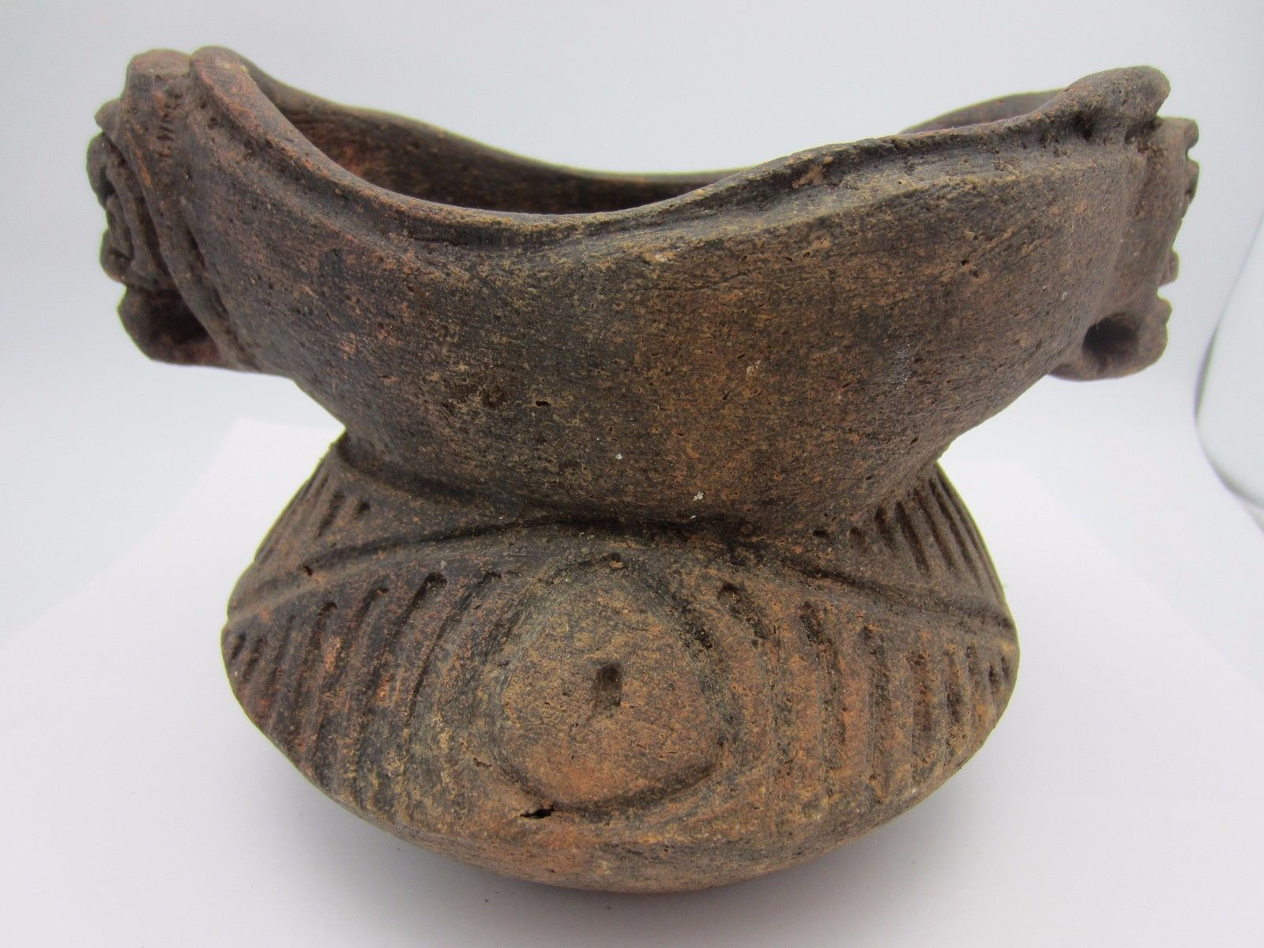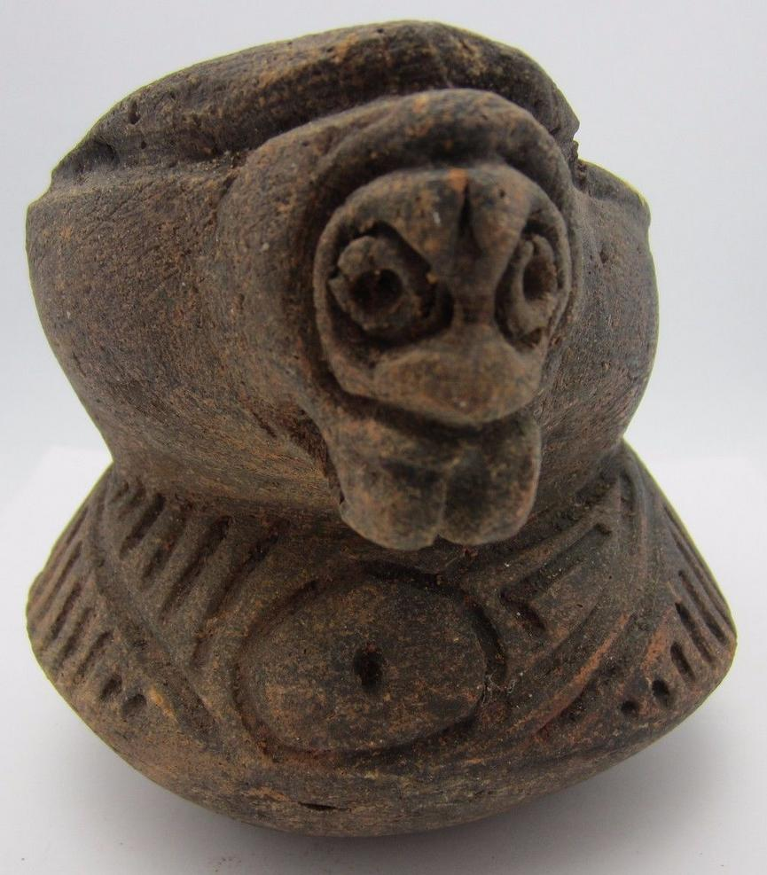 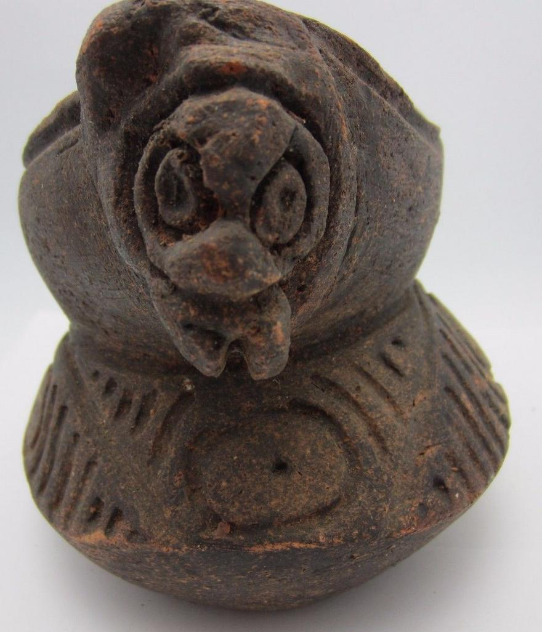

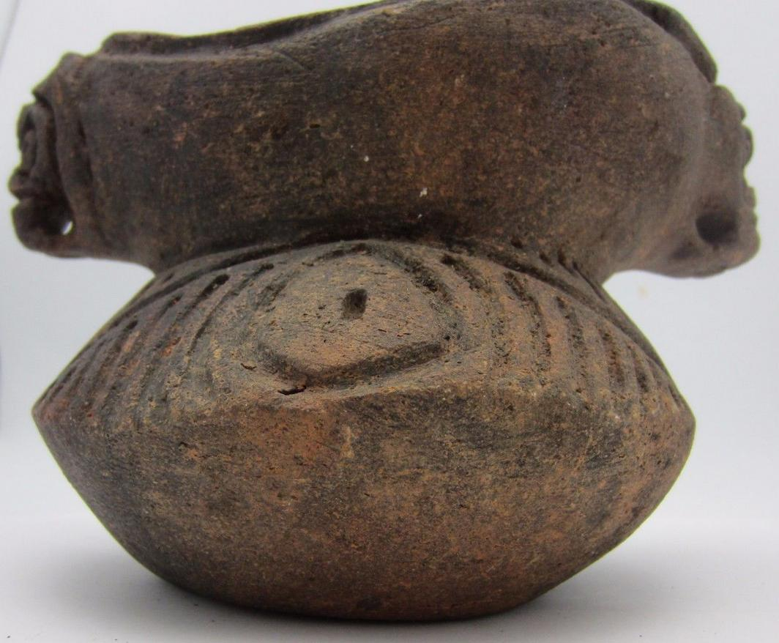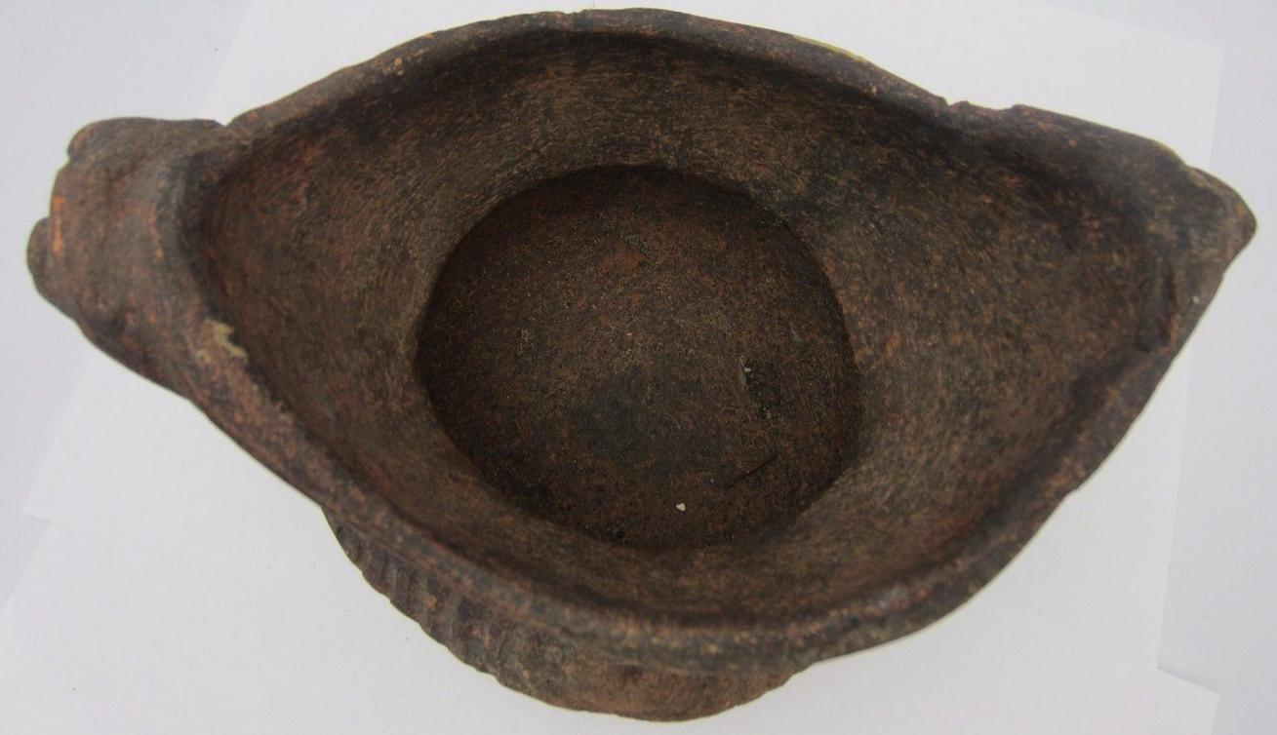

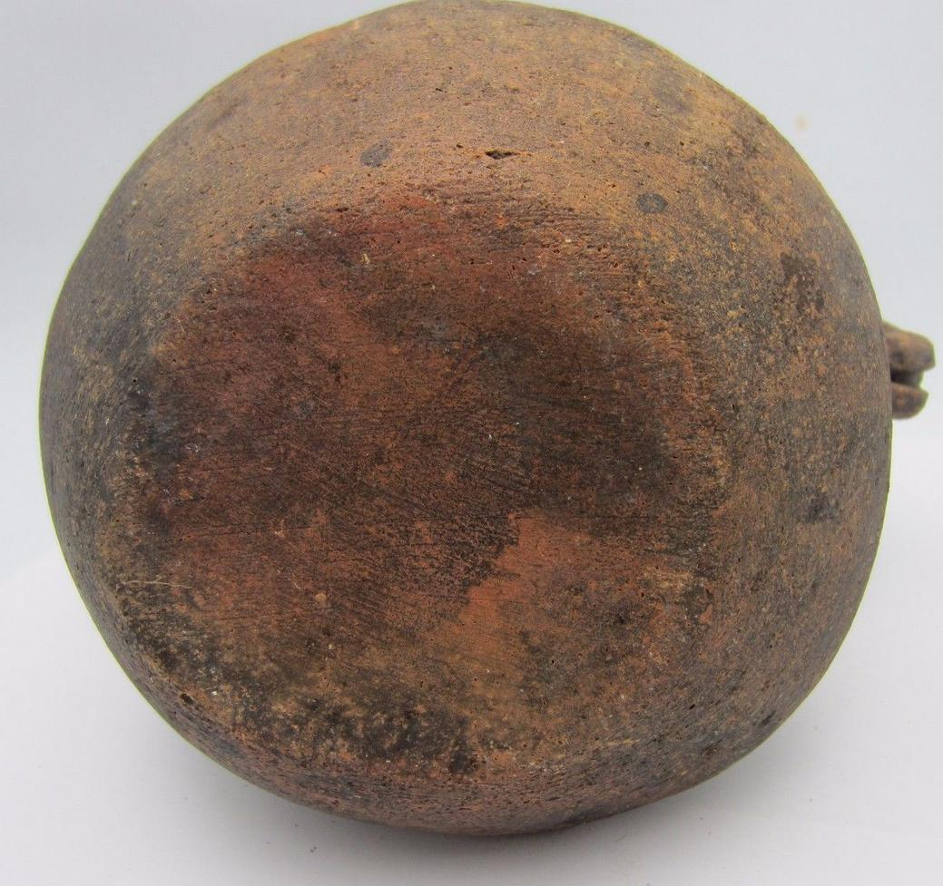

Figs. 1-7. A AM,C-Taino-Cohoba Bowl-Two Cemis Past and Future-Terra cotta-1000 CE

Case No.: 18

**Accession No.**

**Formal Label:** AM,C-Taino-Cohoba Bowl-Two Cemis Past and Future-Terra cotta-1000 CE

**Display Description:**

This terra cotta bowl for holding ground cohoba has cemís or spiritual beings at either end. These are Janus figures, facing past and future, suggesting the flight of the Bohiqie is in no way limited to time. This was used in a ceremonial setting with the Bohique summoning the spirits to assist in his flight to the beyond.

**LC Classification: F1909**

**Date or Time Horizon: 1000 CE**

**Geographical Area: Hispaniola**

**Map:**

**GPS coordinates:**

**Cultural Affiliation: Taino**

**Medium: Terra cotta**

**Dimensions:L 7.5 in**

**Weight:**

**Condition:**

**Provenance: Shafer Jewelers, Miami , Florida**

**Discussion:**

**References:**